# CS 255 System Design Document Template

This template lays out all the different sections that you need to complete for Project Two. Each section has guidance to prompt your thinking. You will need to continually reference the interview transcript as you work to make sure that you are addressing your client’s needs. There is no required length for the final document. Instead the goal is to complete each section based on what your client’s needs are. Remove this note when you are finished, and replace all bracketed text with the relevant information.

## UML Diagrams

### UML Use Case Diagram

*[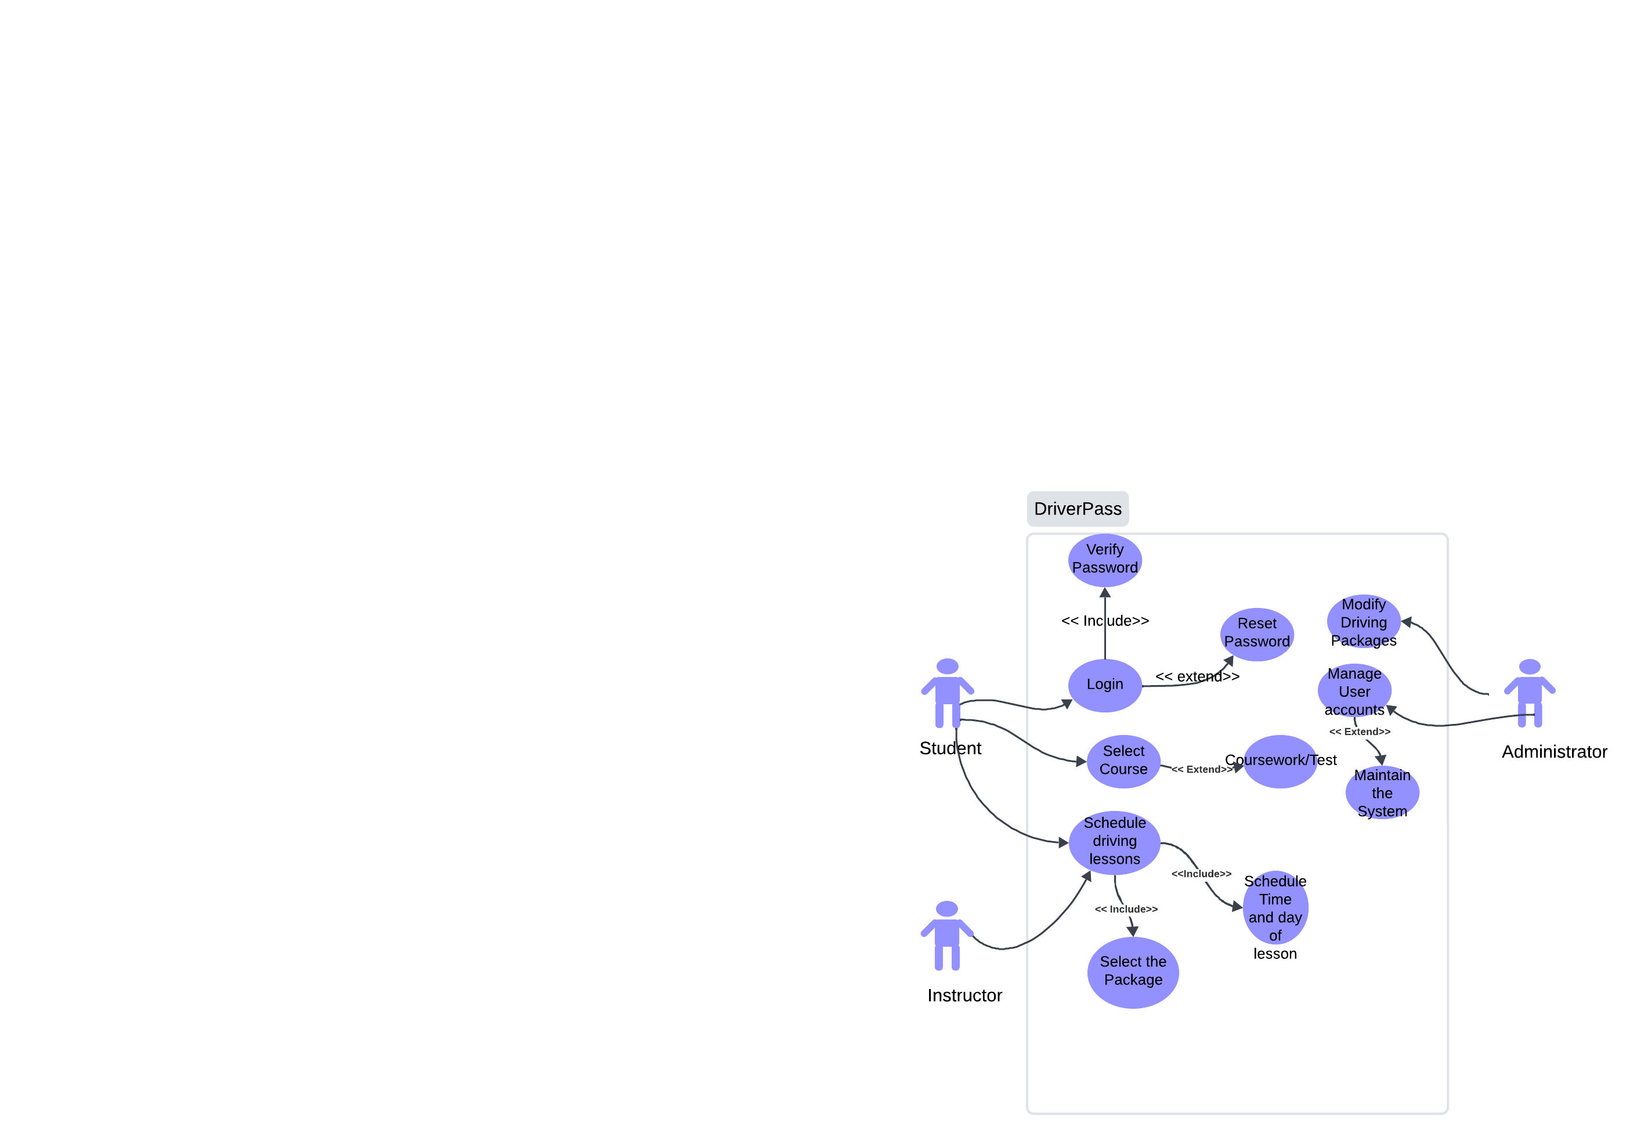*

### UML Activity Diagrams

*[Use case for scheduling an appointment*

*Use case for a student registering for the first time.*

### UML Sequence Diagram

*[Sequence diagram for scheduling a lesson.*

### UML Class Diagram

*[UML class diagram*

*]*

## Technical Requirements

*[One technical requirement for the driver pass system would be a physical web server. The web server should be able to provide service on any device and anywhere. Another technical requirement that driverpass needs is a physical database server. This server hosts the systems databases, including lesson time and dates, user accounts and the different driving packages. A third technical requirement would be devices for students and instructors. In order to access driverpass online, the user would need to use a device like a smartphone or a pc. They would also need to use a web browser like google chrome, Microsoft edge, and firefox.One software requirement for the system is the operating system. An operating system like Unix or Windows Server OS would be good to have as an operating system. The database server would also need a management system like SQL. If you want to be able to access the database online, using a database that’s on the cloud like AWS may be a better option. A security feature that may be added is TLS and SSL, authorization like account lockout may be good to have. Role based Access control is important if each account only gets the permissions they need. The last requirement that may be important is APIs. APIs may be important because driverpass wants to receive updates from the DMV. Making sure each system is compatible with each other can make the update process easier and less errors. ]*